BUSINESS REQUIREMENTS
Uganda Agricultural Aggregation Platform (UGAAP) -BRD
April 2026
Document ID: UGAAP-BRD
Prepared by: E&M Technology House Ltd

Field | Detail
Project Name | Uganda Agricultural Aggregation Platform (UGAAP)
Document Type | Business Requirements Document (BRD)
Version | 1.0
Issue Date | April 2026
Document Owner | E&M Technology House Ltd
Approved By | TBD
Related Documents | UGAAP FRD

Table of Contents
Table of Contents 2
1. Introduction 3
1.1. Background and Context 3
1.2. Business Problem and/ or Opportunities/ Objectives 3
1.3. Current Situation/Environment 3
2. Scope 3
2.1. In-Scope 3
2.2. Out of Scope 3
3. Core Process Definition 3
4. Solution Architecture Outline 3
4.1. Context Diagram 3
5. Definition of Business Requirements 3
5.1. Business Functional Requirements 3
5.2. Non-Functional Requirements 3
5.3. Stakeholder Requirements 3
5.4. Business Process Requirements 3
5.4.1. Cooperation Onboarding 3
5.4.2. Farmer Onboarding 3
4

1.Introduction

1.1Background and Context
Whereas smallholders drive 80% of Uganda’s agricultural output (Food and Agriculture Organisation) , the sector is hindered by paper-based records and financial "blind spots." The Uganda Agricultural Aggregation Platform (UGAAP) intends to resolve these structural gaps by digitizing the value chain to achieve:
- Operational Clarity: Automates debt reconciliation and replaces manual tracking with a real-time digital ledger.
- Scalable Growth: Provides a flexible infrastructure to manage high-volume data across diverse crop and livestock sectors.
- Precision & Transparency: Delivers accurate reporting and a "single source of truth" for payments, reducing errors and building trust.
- Data Security: Protects integrity through localized, independent branch management.

1.2 Business Problem and/ or Opportunities/ Objectives
Category | Description
The Problem | Cooperatives currently rely on fragmented, manual paper trails to manage member transactions, leading to significant operational blind spots.  - Manual Records: Input loans and harvest receipts lack centralized digital tracking.  - Reconciliation Lag: Offsetting debts against deliveries requires weeks of error-prone cross-referencing.  - Opaque Reporting: Reliance on ledger manipulation causes frequent financial disputes and delays.
The Opportunity | - To revolutionize the farmer-cooperative experience through a centralized digital ecosystem (integration and automation) that replaces manual tracking with real-time financial visibility and automated reporting
The Solution will exist for | - For all cooperatives and farmers
The impact / need of which is | Should this initiative not be delivered:  The Cooperative will remain at risk of operational stagnation, failing to provide a seamless digital platform and losing the transparency required to eliminate manual errors and ensure timely farmer payments.
A successful solution would be | To enable a digital-first solution for all cooperatives and farmers to process input distributions and produce deliveries with absolute transparency and auditability
Measured By | - The rate of capturing and recording farmer harvest data  - The reduction in turnaround time for produce delivery assessments  - The total time taken to process and settle farmer payments within a single cycle
Assessed with | There will be an output generated report to display all transactions, consolidating input loans and harvest deliveries to provide a complete audit trail. This report can be used to determine the exact net payments due to farmers and evaluate the time spent on each reconciliation.

1.3 Current Situation/Environment
Cooperatives currently rely on fragmented, paper-based registers that lack the automation necessary to manage agricultural value chains efficiently. This forces farmers to endure manual recording and lengthy settlement delays as input debts are reconciled by hand. The resulting lack of a centralized system creates payment backlogs and deprives management of real-time visibility into branch operations.

2.Scope

2.1 In-Scope

No. | SCOPE | COMPONENT
1 | Products | - Crops  - Livestock
2 | Distribution channels | - Branch Network  - Web based portal  - USSD  - Mobile app
3 | Processes | - Farmer onboarding  - Configuration module  - Branch management  - Input management  - Reconciliation  - Inventory management  - Quality control and grading  - Outstanding payment tracking
4 | Documents Upload and Management | - Word, Excel  - PDF  - JPEG  - E-mail/ Message
5 | Systems Integration | The platform should have the capability to integrate with key systems in the business for seamless performance. These include:  - SMS Gateway – To support automated sending of SMS to customers.  - E-mail exchange – To support automated sending of e-mails to customers.  - Cloud and API ready  - Core Banking  - Weighing Machines  - Enterprise Resource Planning
6 | Reports | The platform should be able to generate various reports for  - Internal use- Reconciliation and Monitoring  - Regulatory Reporting  - Compliance Reporting  - Risk Reports  - Farmer (Statements)  - Audit Logs  The business should be able to define the period for generation of each of the reports i.e.,  - Real time  - Scheduled (End of Day/ Intra-day)  - Ad hoc  The reports should be generated in different formats based on business use/ needs i.e.,  - PDF  - XLS , CSV  - txt  - JSON

3. Core Process Definition
CHARACTERISTIC | DESCRIPTION
Process Context | End-to-end digital tracking of agricultural input distribution and produce recovery in Uganda from structured farmer onboarding through input issuance, produce delivery, quality grading, outstanding balance calculation, repayment recording, and reconciliation.
Process Goal | Provide a configurable platform that:  - Improve coordination between all actors  - Enable efficient tracking of activities and transactions  - Enhance communication amongst the users  - Ensure transparency and accountability  - Simplify user management and access control  - Produces downloadable Excel and PDF reports for external payment execution
As-Is Process | - Input distribution is paper-based with no formal repayment tracking.  - Produce delivery records are kept In excel / Paper Based / Microsoft access at branch level without consolidation.  - Farmer balances (what they owe and what they are owed) are not systematically calculated.  - Reconciliation between input records and delivery records takes weeks and is prone to dispute.
To-Be Process | - Farmer is registered and onboarded through a structured digital workflow. Admin configures crops, livestock types, stock items, seasons, and repayment terms via the Configuration Module.  - Inputs are recorded against individual farmers with auto-calculated repayment obligations.  - Farmer delivers produce; agent records delivery on the platform quality grade assigned; outstanding payment amount calculated and stored.  - SMS sent to farmers containing their transaction details.  - Repayments are recorded and outstanding balances updated in real time.
Business Rules | - All repayment schedules  - Deduction logic, and fee structures are parameter-driven and configurable per crop/livestock type, season, and branch.  - All financial figures in the system represent obligations and records, not executed transactions.  - Farmers can only be seen by their own branch manager , Collection officer, the admin / cooperative
Exception Handling | - Delivery correction with collector guy audit trail.
Actor | - Platform Admin  - Cooperatives  - Branch Managers  - Farmers  - Collection Officers  - Finance

4. SOLUTION ARCHITECTURE OUTLINE

4.1 Context Diagram

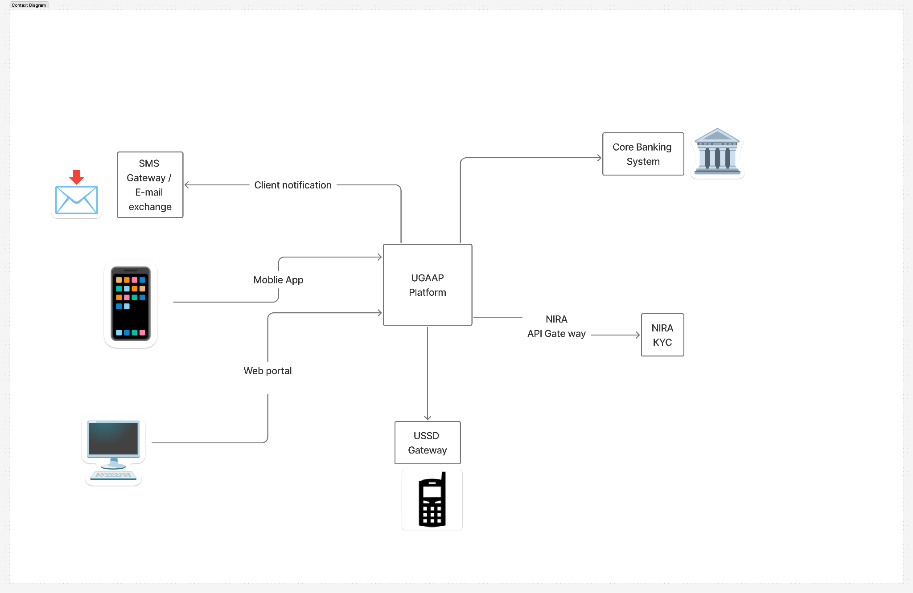

5. DEFINITION OF BUSINESS REQUIREMENTS
5.1 FUNCTIONAL BUSINESS REQUIREMENTS
REQ ID | REQUIREMENT | DESCRIPTION | SYSTEM
RQ1 | Configuration management module | Crop Type Management.  Livestock Type Management.  Stock Item Type Management.  Role and Permission Management.  Grading Engine.  (Grading Standards Configuration)  Workflow | Platform
RQ2 | Inventory Management  module | Stock -Tracking | Platform
RQ3 | Accounting Management  module | Payment Schedule Configuration.  Deduction Tables for collectors / Inventory table or disbursement table | Platform
RQ4 | Notification management module | Notification Template Management.  Farmer Notifications.  Event-Based Notifications. | Platform
RQ5 | Reporting management module | Payment Reports  Scheduled Reports.  Inventory report | Platform
RQ6 | Member management module | Multi-stage Onboarding Workflow.  Member management  Bulk Farmer Upload. | Platform
RQ7 | Reconciliation management module | Reconciliation model. | Platform
RQ8 | Audit management module | Audit Trail. | Platform

5.2 NON-FUNCTIONAL REQUIREMENTS
REQID | REQUIREMENT | DESCRIPTION
NFRQ1 | API Response Time | Critical operations must respond within seconds under normal load conditions
NFRQ2 | Concurrent Users | The solution must support concurrent users without performance degradation.
NFRQ3 | Daily Transaction Volume | The system must handle multiple delivery transactions per day during peak season
NFRQ4 | Report Generation | Standard reports must be generated within seconds
NFRQ5 | Uptime SLA (Service Level Agreement) | During active aggregation seasons, the system must maintain an optimum response time possible.
NFRQ6 | USSD | This functionality must be available offline·
NFRQ7 | Data Recovery | Automatic failover to secondary region must be supported  Recovery Time Objective (RTO)  Recovery Point Objective (RPO)
NFRQ8 | Encryption | TLS 1.3 for data in transit  AES-256 for data at rest for all PII and financial records
NFRQ9 | Authentication | OAuth 2.0 with JWT must be implemented  OTP 2FA mandatory for all administrative and financial recording operations
NFRQ10 | Branch Data Isolation | Database-level enforcement of branch data isolation  No cross-branch data leakage must be possible
NFRQ11 | Compliance | The solution must comply with Uganda Data Protection and Privacy Act 2019
NFRQ12 | Farmer Registry Scalability | The solution must support multiple registered farmers per tenant
NFRQ16 | Web Portal Usability | Support for Chrome, Firefox, Safari, and Edge browsers
NFRQ17 | Android App Usability | Support for Android 4.4+  Offline-capable  Optimized for low-bandwidth 3G networks
NFRQ18 | USSD Usability | Operable on any feature phone connected to any telecommunication provider.
NFRQ21 | Data Retention | Configurable depending on organisation needs

5.3 STAKEHOLDER REQUIREMENTS
REQID | REQUIREMENT | DESCRIPTION | STAKEHOLDER
SHRQ1 | API Response Time Accountability | Critical operations response time in seconds must be measurable and reportable to ensure service level compliance | Operations
SHRQ2 | Transaction Volume Assurance | The business must have visibility of daily transaction volumes at peak capacity to ensure no service disruption during peak seasons | Business Lead
SHRQ3 | Offline Operations Continuity | For field operations, the Android app must function fully offline with automatic sync to ensure no loss of data or productivity in low-connectivity areas | Aggregator Team
SHRQ4 | Disaster Recovery Verification | The 4-hour RTO and 1-hour RPO must be tested and certified by the business continuity team on a semi-annual basis | Risk & Compliance
SHRQ5 | Branch Data Segregation | The system must provide audit reports demonstrating that no cross-branch data leakage has occurred, for regulatory and internal risk management purposes | Compliance, Risk
SHRQ6 | Regulatory Compliance (Uganda) | The solution must provide evidence of compliance with Uganda Data Protection and Privacy Act 2019, including data subject access, deletion, and consent management capabilities | Regulatory Affairs, Legal
SHRQ8 | Farmer Registry Capacity | The solution must support reporting and querying across registered farmers per tenant without performance degradation | Data Office, Operations
SHRQ9 | Tenant Onboarding SLA | New tenant onboarding must be completed and possible | Project Manager, Business Lead
SHRQ10 | Accessibility Compliance | Web portal must be compliant to ensure accessibility for all users. | Compliance, HR
SHRQ11 | USSD Feature Phone Support | USSD functionality must be tested and verified on network providers at 2G/EDGE speeds to ensure no exclusion of rural farmers with basic phones | Business Lead, Digital Channels
SHRQ13 | Audit Trail | The audit log must be immutable (cannot be altered or deleted) and must capture all user actions, configuration changes, and financial reconciliation events for fraud investigation purposes | Fraud, Internal Audit
SHRQ14 | Legal Data Retention | Data retention will be automatically configurable per organisation | Legal, Compliance, Data Office

6. BUSINESS PROCESS REQUIREMENTS

Cooperative On boarding.

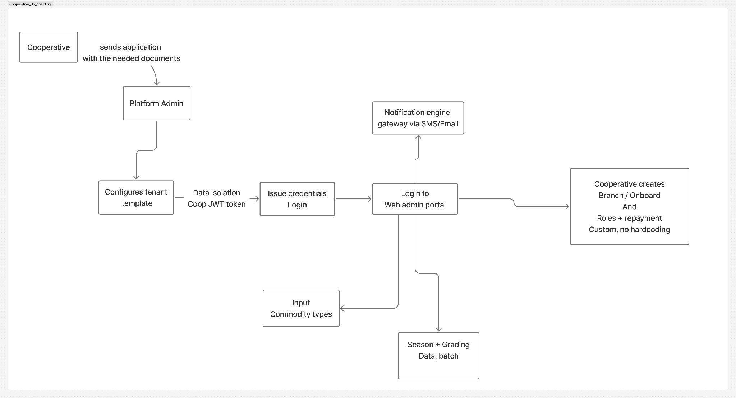

Farmer On boarding.

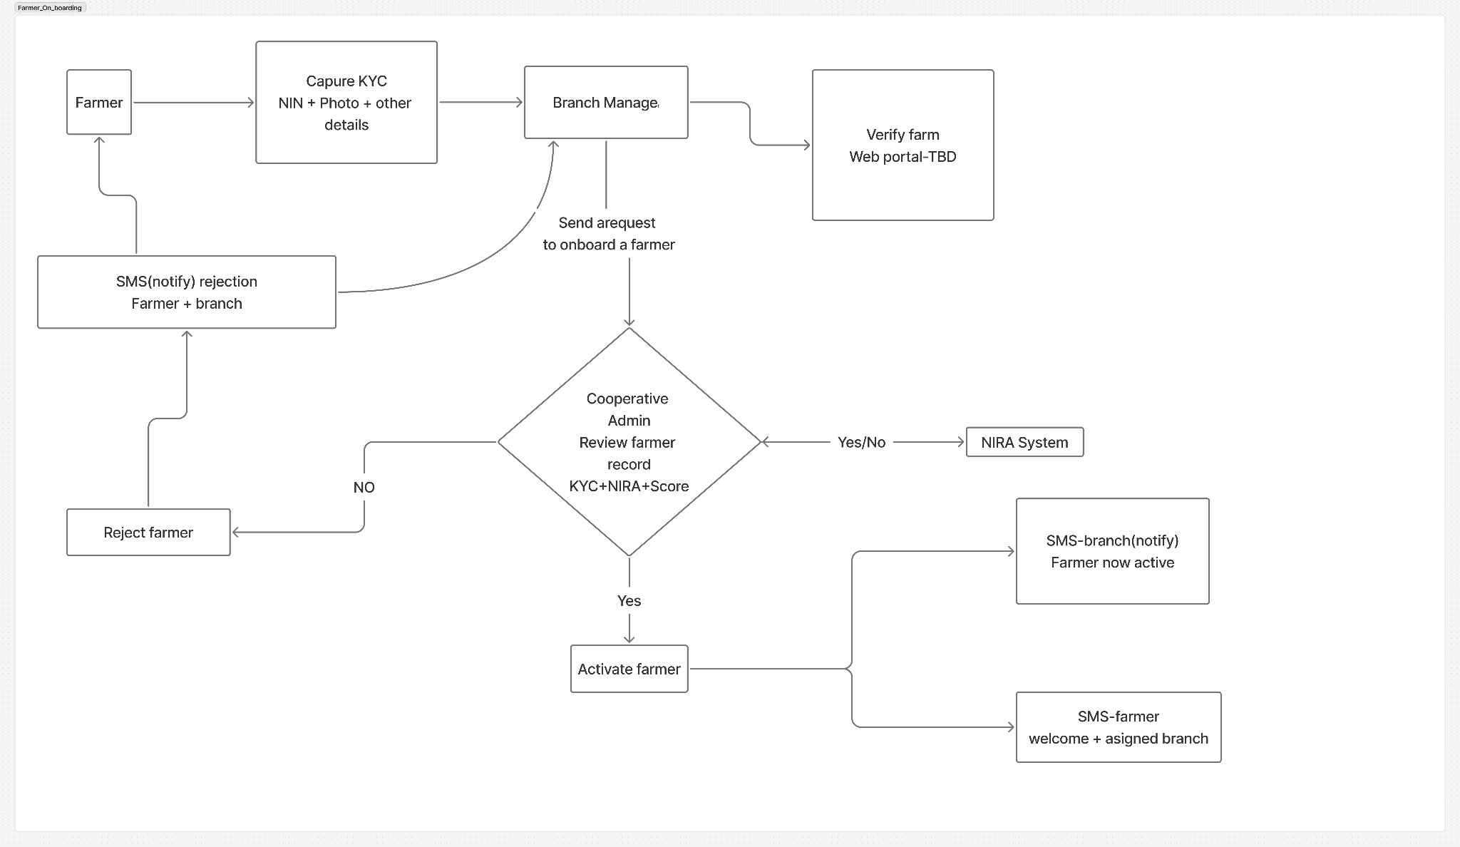

Inventory

